**CHAT BOAT FOR PLACEMENT**

END TERM REPORT

BY

Section – K18HV

|  |  |
| --- | --- |
| **NAME OF THE CANDIDATE(S)** | **ROLL NO** |
| Harjot Singh | 10 |
| Rishabh Bansal | 11 |
| Abhinandan Mahajan | 19 |
| Ujjwal Chaturvedi | 09 |



**Department of Intelligent Systems**

**School of Computer Science Engineering**

**Lovely Professional University, Jalandhar**

**APRIL 2020**

**Student Declaration**

This is to declare that this report has been written by me/us. No part of the

report is copied from other sources. All information included from other sources

have been duly acknowledged. I/We aver that if any part of the report is found to

be copied, I/we are shall take full responsibility for it.

Name of Student Ujjwal Chaturvedi



Roll number: 09

Name of Student Abhinandan Mahajan

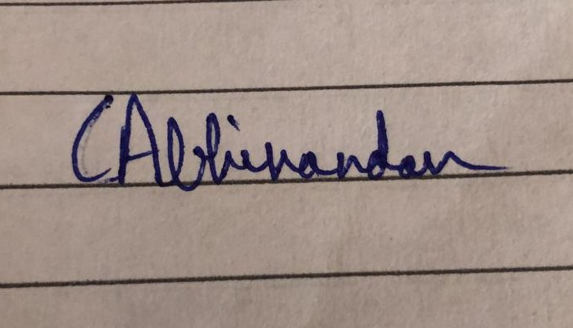

Roll number: 19

Name of Student Harjot Singh



Roll number: 10

Name of Student Rishabh Bansal

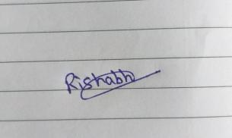

Roll number: 11

**TABLE OF CONTENTS**

**TITLE PAGE NO.**

**1. Background and objectives of project assigned .............................**

1.1Background......................................................................................

1.2 Objectives ........................................................................................

1.3 Introduction …………………………………………………..

**2 Description of Project ...........................................................**

2.1 Description ...........................................................

2.2 System overview ...........................................................

2.3 Packages Used ...........................................................

**BONAFIDE CERTIFICATE**

Certified that this project report “ CHAT BOT FOR PLACEMENT ” is the

bonafide work of “Rishabh Bansal , Harjot Singh , Abhinandan Mahajan , Ujjwal Chaturvedi” who carried out the project work under my supervision.

Signature of the Supervisor

Dipen Saini

Academic Designation

ID of Supervisor

Department of Supervisor

**1.1 Background of Chatbot:-**

A chatbot is a software application used to conduct an on-line chat conversation via text or text-to-speech, in lieu of providing direct contact with a live human agent. Designed to convincingly simulate the way a human would behave as a conversational partner, chatbot systems typically require continuous tuning and testing, and many in production remain unable to adequately converse or pass the industry standard Turing test. The term "ChatterBot" was originally coined by Michael Mauldin (creator of the first Verbot) in 1994 to describe these conversational programs.

Chatbots are typically used in dialog systems for various purposes including customer service, request routing, or for information gathering. While some chatbot applications use extensive word-classification processes, Natural Language processors, and sophisticated AI, others simply scan for general keywords and generate responses using common phrases obtained from an associated library or database.

**1.2 Objective of Chatbot**

- Guide the user through the conversation not to let him wonder what he should do or say

- Cover all possible answers and questions for core bot use cases

- Support various small talk intents, the more the better!

- Great opportunities present with artificial intelligence-based chatbots and you must identify opportunities

- To establish real-time engagement with your customers.

- 365X24X7 Support — Unlike your support staff, Chatbots don’t need any breaks, they happily

- work and learn 24 hours a day. They have a robust cloud architecture.

- Reduce operational and service expense

- Get a new age platform to wow your customers

- Increase engagement with customers and touchpoints

- Eliminate mobile app-fatigue

- Multiply reach, increase breadth and depth of engagement

- Rich analytics and customer interaction

- Instantaneous response without the need for human response delays

**1.3 Introduction: -**

This System is a Chat bot which provides answer to the query of the student. The query of the Students is generally a chat.

The chat is done in any manner, there is no particular format declared for chatting with the bot. The main goal is to reduce the job of the students to personally visit the college. The system provides information about college related activities. The system consists of graphical user -friendly interface. System uses A.I. and M.L. for solving the queries. The user can ask questions related to college related activities such as date and timing of annual day, sports day, and other cultural activities.

**2.1 Description: -**

This project is based on Chatbot which is eligible to handle most of the queries related to placement Services.

In artificial intelligence ... machines are made to behave in wondrous ways, often sufficient to dazzle even the most experienced observer. But once a particular program is unmasked, once its inner workings are explained ... its magic crumbles away; it stands revealed as a mere collection of procedures ... The observer says to himself "I could have written that". With that thought, he moves the program in question from the shelf marked "intelligent", to that reserved for curios ... The object of this paper is to cause just such a re-evaluation of the program about to be "explained". Few programs ever needed it more.

Today, most chatbots are accessed on-line via website popups, or through virtual assistants such as Google Assistant, Amazon Alexa, or messaging apps such as Facebook Messenger or WeChat. Chatbots are typically classified into usage categories that include: commerce (e-commerce via chat), education, entertainment, finance, health, news, and productivity.

**2.2 System Overview**

In our Chatbot System, we have designed a Chatbot using Python programming. First bot analyses user’s queries and understand user’s message, based on bot knowledge bot provide answers to the queries of the students. Students will just have to ask the questions to the bot that will be used for chatting. Student can query related to admission, faculty details, etc. Students don't have to go to the college or contact the faculty to make the enquiry. If any new candidate enquirers for admission and the details about any department of the college this bot will help to get the answer of query of the candidate and even while getting the answer the bot will read out the answer to the candidate.

**2.3 Packages Used**

Chatterbot for implementing machine learning in chatbot

ListTrainer for training the Chatbot

pyttsx3 for audio based output of the Chatbot

speech_recognition for getting voice based input

tkinter for impleting GUI of Chatbot

threading for implementing multi threading